Network Traffic Anomalies Detection Using Machine Learning Algorithm: A Performance Study

Md. Azam Hossain¹, Iqram Hussain^{2,3}, Baseem Al-Athwari⁴, Santosh Dahit⁴
¹ Network and Data Analysis Group, Department of Computer Scinece and Engineering
¹Islamic University of Technology, Gazipur, Bangladesh
2Korea Research Institute of Standards and Science, Daejeon, South Korea
³University of Science & Technology, Daejeon, South Korea
⁴Kyungdong University, Goseong-gun, Gangwon-do, South Korea,
azam@iut-dhaka.edu, iqram@kriss.re.kr, baseem@kduniv.ac.kr and santoshdahit454@gmail.com
Abstract. Internet of Things (IoT) has recently introduced the idea of connecting everything to the internet. Due to the growth in internet use, cyber security firms have been compelled to develop more sensitive systems in addition to conventional security techniques. As a consequence, proactive cyber security solutions including network behavior monitoring, machine learning, and threat analysis are being created. In today's world, intrusion detection systems (IDS) are one of the technologies that are often utilized to combat cyber threats. In this paper, we provide a performance analysis of machine learning-based network intrusion detection systems. Numerous machine learning techniques are employed to categorize any unusual behavior seen in network traffic. In this study, support vector machines (SVM), random forest (RF), logistic regression (LGR), and artificial neural network (ANN) models were utilized to identify and detect malicious activity. Furthermore, we evaluate the effectiveness of machine learning models for Network Intrusion Detection and derive useful insights.

Keywords: Machine Learning, Intrusion Detection, Anomaly Network Traffic, Cyber Threat, Security.
- Introduction
With the widespread use of the Internet, the world has seen a slew of new innovations and technical advancements [1]. Organizations and governments all around the globe have been pushed by economic advancements to create and utilize cutting-edge networks. These networks integrate security features like as encryption, data integrity, and authentication, as well as technology such as distributed storage systems, voice over Internet Protocol (VoIP), wireless access, and online services.
In order to maintain a reliable and stable service to its consumers, organizations and institutions are continuously increasing their spending on cyber defense solutions. The Cyber Security Market, which was valued at over USD 230 billion in 2021, is anticipated to reach USD 430 billion by 2030, according to a study released by Global Opportunity Analysis and Industry Forecast in June 2021 [2]. The growth of cloud services and devices like the Internet of Things, according to this research, has raised the danger of network attacks. The graph in Fig. 1 shows the size of the cyber security industry according to 2019-2030 released by Global Opportunity Analysis and Industry Forecast [2].
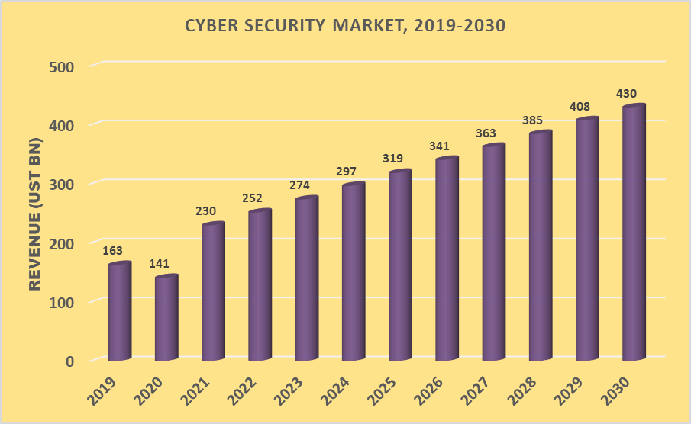
Fig. 1. Global Cyber Security Market Forecast 2019-2030
Cyberattacks may have much more widespread consequences than in the past, according to a Deloitte study [3], due to the interconnected nature of Industry 4.0-driven activities and the rapid speed of digitalization. Furthermore, as shown in Fig.2, according to projections, the total number of Internet of Things (IoT) linked devices deployed globally would reach 30.9 billion units by 2025, representing a significant jump from the 13.8 billion units anticipated in 2021[4].
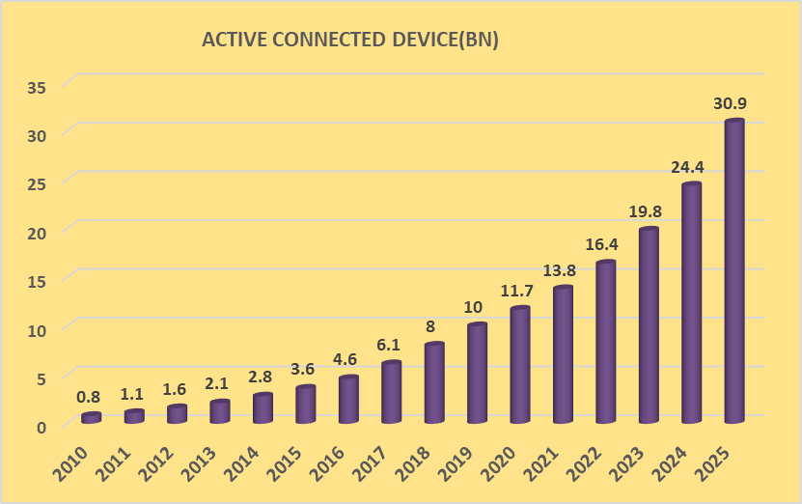
Fig. 2. Global Deployment of Internet of Things (IoT)-Connected Devices
Nowadays, a large proportion of business groups offer access to their network through intranet and web; the goal is to empower customers to connect to the systems via web-based business exchanges that enable representatives to access data via virtual private systems [5]. As a result of this use, it becomes more vulnerable to attacks and intrusions into the network. Security threats arise not just from external intruders, but also from inside the company, in the form of system misuse and exploitation. The firewall has no use other than to limit network access; it is incapable of defending the network against intrusion attempts. On the other side, the Intrusion Detection System (IDS) is capable of detecting anomalous network activities [6].
Network Intrusion Detection System (IDS) is often installed or positioned at strategic locations across the network to protect traffic that is most likely to be susceptible to attack. In general, it is deployed to whole subnets and tries to match any passing traffic to a library of known threats. When it comes to detecting potential threats, IDS systems use either signature-based or rule-based approaches. In signature-based detection, it compares data in the network with attack patterns stored in its database and an alert is triggered if a match is discovered. However, it has significant drawback of not being able to identify attacks that aren't already in the IDS database. In rule-based systems, also known as anomaly-based IDS, the IDS database stores normal behavior states. These systems keep an eye on every network activity. When a deviation from the stated rules occurs, an alert is produced. The primary benefit of anomaly-based intrusion detection systems is their ability to identify previously undetected threats [7-8].
Fig. 1 reflects that the expenditures are growing all the time high in order to offer secure and reliable service to end customers by the enterprises. Methods such as network activity analysis and machine learning are being utilized to identify threats as early as possible. Intrusion detection systems have thus emerged as the most existing research topics in cyber security domain. In this article, we provide a comparative analysis of network intrusion detection systems that are based on machine learning techniques. In order to classify any anomalous behavior seen in network traffic, a variety of machine learning methods are used. In this research, support vector machines, random forests, logistic regression, and artificial neural network models were used to identify and detect malicious behavior in order to identify and detect malicious activity. For the purpose of evaluating the effectiveness of machine learning models for network intrusion detection, we utilized the KDD99 dataset [9].
The remainder of the study is divided into the following sections. In section 2, we provide an overview of related works. Section 3 presents datasets from the IDS that are available to the public. Sections 5 and 6 provide the suggested technique as well as the experimental findings obtained via this method. Sections 7–9 conclude with a discussion of the findings, as well as recommendations for further research.
- Literature Review
In the literature, machine learning methods have been used extensively to study IDS. For instance, the authors of [10] utilized support vector machines (SVMs) to identify abnormalities in the KDD dataset. The authors of [11] used the same dataset to develop IDS models for anomaly detection using artificial neural networks. In [12], the author demonstrated how to utilize cascaded classifiers to identify and classify anomalies in the KDD dataset, even when the anomalies were not evenly distributed. The identification of anomalies using random forest (RF) has been suggested in [13]. Additionally, [14] proposes hybrid methods that combine two or more machine learning algorithms. The results indicate that hybrid methods outperform single models.

With the KDD dataset, the authors in [15] developed a four-layered classification method to identify four different kinds of attack. The findings show that there is a minor misclassification error as well as a little total error. Furthermore, the authors suggested reducing the number of variables in the original dataset, which resulted in less complexity and improved accuracy. The authors, however, did not disclose the misclassification errors that occurred as a consequence of a particular kind of attack being misclassified as another type. The study in [16] provided similar information utilizing the same dataset and several learning methods, including supervised, unsupervised, and outliers learning. The findings revealed that certain assaults were incorrectly categorized, and as a consequence, the overall accuracy was lower than that of the study given in [15]
To classify IDS systems faster and more effectively, the authors in [17] proposed that the attributes representing the entire data collection should be revealed. As a result, they used genetic algorithm-based wrapper logistic regression to choose the optimal features for the intrusion detection system. KDD99 and UNSW-NB15 were used to evaluate their approaches.
The authors in [18] employed a statistical method based on the Dynamic threshold algorithm to identify distributed denial of service (DDoS) attacks. The approach was tested using dataset from the DARPA project. In terms of detection rates and processing time, the proposed scheme outperformed existing approaches based on the results of the experiments. Study conducted in [19] classified the KDD Cup 99 dataset using NB, Bayes Net, Random Forest, Multilayer Perception (MLP), and Sequential Minimal Optimization (SMO) methods.
- Experiment and Methodology
Using monitoring, detection, and response to unauthorized activity inside the network, an intrusion detection system (IDS) should be able to detect and identify any aberrant patterns and traffic. Due to its large and imbalanced datasets, IDS, on the other hand, faces a complete data processing issue. As a result, several methods for dealing with this issue have been proposed and evaluated.
This section provides a summary of the various models that were utilized in the research, followed by a short discussion of the metrics that were used to assess the findings.
  - Model
Decision Tree-Based Random Forest: Decision trees are used to build random forests. Random forests enhance accuracy by combining the simplicity of decision trees with flexibility. Random forest, as the name implies, is a collection of independent decision-making trees that work together as a unit. Random forest trees each propagate a class forecast, and the model's prediction is the class with the most votes. For better predictions, the trees should have low or no correlations. In ML, it may be utilized for tasks like as Classification and Regression.
The Support Vector Machine (SVM) is a class of machine learning algorithms that is the most widely used technique of classical classification and analyze data in order to find patterns. This technique's main objective is to project nonlinear separable samples onto a higher-dimensional space utilizing various kinds of kernel functions. It is defined formally by a separating hyperplane. In other words, the algorithm generates an optimum hyperplane for categorizing fresh instances given labeled training data.
Despite its name, logistic regression is a classification model rather than a regression model, and it is used to classify data. Logistic regression is a guided classification method in which a model in which the dependent variable is categorical, i.e. either 1 or 0, is used to classify a dependent variable. The inputs, together with their associated weights, are taken and compressed into a nonlinear function, such as a sigmoid function. This generates a number between 0 and 1, which corresponds to the probability that the class is a member of it in the first place. As opposed to linear regression, in logistic regression we fit a "S" shaped logistic function, which predicts two maximum values instead of a regression line (0 or 1). Logistic regression may be used to classify observations using a variety of different kinds of data, and it can be used to quickly identify which factors are the most efficient for classifying observations.
Artificial Neural networks, one of the most common machine learning algorithms, include a wide variety of ideas and methods. Neural networks are an aesthetically pleasing biologically inspired programming paradigm that allows a computer to learn from observational data. It is loosely based on our current understanding of how the human brain functions. To begin, a collection of software "neurons" is formed and linked, enabling them to communicate with one another. Following that, the network is tasked with solving a problem, which it repeatedly tries, each time strengthening the connections that lead to success and eroding those that lead to failure.
  - Dataset Acquisition and Description:
When it comes to evaluating anomaly detection techniques, the KDD'99 data set has been the most often used. Approximately 4,900,000 single connection vectors with 41 features each are included in the KDD training dataset [20]. Each connection vector is classified as either normal or an attack, with only one particular attack type included. The simulated assaults are divided into four categories: Denial of Service Attack (DoS), User to Root Attack (U2R), Remote to Local Attack (R2L), and Probing Attack. The DoS attack is the most common kind of simulated attack. In the KDD 99 dataset, there are twenty-two (22) distinct kinds of assaults to be found. As indicated in Table 1, there are four major kinds of attacks types to consider.
  - Evaluation Matrices:
A confusion matrix is a two-by-two table that contains the output of binary classifiers. True Positives (TP), True Negatives (TN), False Positives (FP), and False Negatives (FN) are the components of this matrix, as described below. The confusion matrix may be used to determine different metrics like as accuracy, precision, and recall.
Table 1. Summery of KDD Dataset Attack Profile
Attack Category | Types of Attacks
DOS | Land, Back, Neptune, Pod, Smurf, Teardrop
R2L | Ftp Write, Guess Password, IMAP, multi hop, PHF, Spy, Warez client, Warezmaster
U2R | Perl, Buffer Overflow, Module Load, Rootkit
Probe | Ip-sweep, Nmap, Port Sweep, Satan

The confusion matrix may be used to evaluate different metrics like as accuracy, precision, and recall.
- True Positives (TP): The number of malicious or anomalous actions identified properly.
- True Negatives (TN): The number of normal behaviors properly identified.
- False Positives (FP): The number of instances when normal behaviors are categorized incorrectly as anomalous behaviors.
- False Negative (FN): The number of harmful or anomalous actions categorized falsely as normal.
Accuracy: Accuracy is the proportion of correctly labelled packets that are malicious or natural. In other words, this is a ratio of properly identified packets to total classified packets. The formulas provide accurate results:
Accuracy = TP + TN / (TP + TN + FP + FN)
Precision: Precision determines how many malicious packets are properly listed among the both of which are listed as malicious. The following formula calculate the precision:
Precision = TP / (TP + FP0
Recall: The term "recall" refers to the number of malicious packets that have been properly classified among all confidential malicious packets. This formula yields the following recall value:
Recall = TP / (TP + FN)
F1 Score: The F1 Score is a weighted average of the precision and recall. False positives and negatives are also included in this score.
F1 score = 2(Recall ∗ Precision) / (Recall + Precision)
  - Comparative Performance Analysis
According to the various evaluation matrices that we mentioned before, we obtained different results for the different models that we utilized in our experiment, which are given in the following Table 2. In comparison to other algorithms, Random Forest has the best classification accuracy. The accuracy averages for models are shown in table 2, including support vector machine (SVM), Random Forests (RF), Logistic Regression (LGR), and Artificial Neural Network (ANN), each of which has an accuracy of 99.91%, 99.97%, 98.81%, and 99.48 percent, respectively.
Table 2 shows that various methods have varying precision average values for the attack features. SVM has 99.89%, RF has 99.96%, LGR has 98.80%, and ANN has 98.27%. As a consequence, Random Forest outperforms other algorithms in terms of models’ precision. When comparing the Recall values shown in Table 2 , Random Forests has the highest recall average with 99.97%, followed by SVM with 99.90%, LGR with 98.67%, and ANN with 99.48%. We also compare the f1 score for Random Forests (RF), SVM, LGR, and ANN. The f1 score for Random Forests (RF), SVM, LGR, and ANN is 99.97%, 99.90%, 98.78$%, and 99.34% respectively.

Table 2. Comparative Performance Analysis of Four Different Model
Matric→ | Accuracy | Precision | Recall | F1 Score
Model Name
Random Forest | 99.97% | 99.96% | 99.97% | 99.97%
SVM | 99.91% | 99.89% | 99.90% | 99.90%
LGR | 98.81% | 98.80% | 98.67% | 98.78%
ANN | 99.48% | 99.27% | 99.48% | 99.34%
  - Results obtained from cross validation:
We obtained extremely good accuracy results for all of the methods, and we utilized cross validation to determine whether or not our dataset was overfitted, as described in the preceding part of this paper. We obtained a value that was quite close to the one we obtained before shown in Table 3. This indicates that our output is not overfitted and that we are getting precise results.
Table 3. Comparative Performance Result of Cross Validation
Matric→ | Accuracy | Precision | Recall | F1 Score
Model Name
Random Forest | 99.97% | 99.96% | 99.97% | 99.97%
SVM | 99.91% | 99.90% | 99.92% | 99.91%
LGR | 99.10% | 99.14% | 98.97% | 98.98%
ANN | 99.48% | 99.37% | 99.48% | 99.41%
As shown in Table 4, we may conclude that each algorithm requires a different amount of time to train and test, and that the time required varies from method to method. When compared to other methods, random forest models are significantly quicker at both training and testing.
Table 4. Comparison of RF, SVM, LGR & ANN Models Testing and Training Time in Second.
Model Name | Training Time (S) | Testing Time (S)
Random Forest | 41.7 | 16.0
SVM | 260.7 | 61.8
LGR | 159.1 | 1.4
ANN | 261.0 | 7.5
- Conclusion
Four classifiers are employed in this study to identify network intrusion: Random Forest, SVM, LGR, and ANN, and their performance is assessed using the KDD dataset. The experimental findings indicate that the Random Forest model outperforms the other models in terms of accuracy. As a result, it can be stated that RF may be utilized to effectively build an IDS. Additionally, we see that the RF model needs very little training time and that the Logistic regression model requires much less testing time.

References

- Hossain MA, Al-Athwari B. Blockchain-Based IoT Forensics: Challenges and State-of-the-Art Frameworks. InArtificial Intelligence and Blockchain for Future Cybersecurity Applications 2021 (pp. 361-376). Springer, Cham.
- Global Opportunity Analysis and Industry Forecast, 2021-2030, 2021, available https://www.nextmsc.com/report/cyber-security-market (Access October, 10 2021).
- Waslo R, Lewis T, Hajj R, Carton R. Industry 4.0 and cybersecurity: Managing risk in an age of connected production. Erişim tarihi. 2017 Mar 21;15.
- Vailshery LS. IoT and non-IoT connections worldwide 2010-2025. 2021 Available: https://www.statista.com/statistics/1101442/iot-number-of-connected-devices-worldwide/#statisticContainer (Access October, 10 2021).
- Kilincer IF, Ertam F, Sengur A. Machine learning methods for cyber security intrusion detection: Datasets and comparative study. Computer Networks. 2021 Apr 7;188:107840.
- Hajialian H, Toma C. Network anomaly detection by means of machine learning: random forest approach with apache spark. Informatica Economica. 2018 Oct 1;22(4):89-98.
- Abrar I, Ayub Z, Masoodi F, Bamhdi AM. A machine learning approach for intrusion detection system on NSL-KDD dataset. In2020 International Conference on Smart Electronics and Communication (ICOSEC) 2020 Sep 10 (pp. 919-924).
- Depren O, Topallar M, Anarim E, Ciliz MK. An intelligent intrusion detection system (IDS) for anomaly and misuse detection in computer networks. Expert systems with Applications. 2005 Nov 1;29(4):713-22.
- Özgür A, Erdem H. A review of KDD99 dataset usage in intrusion detection and machine learning between 2010 and 2015. PeerJ Preprints. 2016 Apr 14;4:e1954v1.
- Rios AL, Li Z, Bekshentayeva K, Trajković L. Detection of denial of service attacks in communication networks. In2020 IEEE International Symposium on Circuits and Systems (ISCAS) 2020 Oct 10 (pp. 1-5). IEEE.
- Novikov D, Yampolskiy RV, Reznik L. Anomaly detection based intrusion detection. InThird International Conference on Information Technology: New Generations (ITNG'06) 2006 Apr 10 (pp. 420-425). IEEE.
- Zainaddin DA, Hanapi ZM. Hybrid of fuzzy clustering neural network over NSL dataset for intrusion detection system. Journal of Computer Science. 2013 Mar 1;9(3):391.
- Almubayed A, Ali H, Atoum J. A model for detecting tor encrypted traffic using supervised machine learning. International Journal of Computer Network and Information Security. 2015 Jun 1;7(7):10.
- Han SJ, Cho SB. Evolutionary neural networks for anomaly detection based on the behavior of a program. IEEE Transactions on Systems, Man, and Cybernetics, Part B (Cybernetics). 2006 Jun 5;36(3):559-70.
- Halimaa A, Sundarakantham K. Machine learning based intrusion detection system. In2019 3rd International conference on trends in electronics and informatics (ICOEI) 2019 Apr 23 (pp. 916-920). IEEE.
- Chen Z, Yeo CK, Lee BS, Lau CT. Autoencoder-based network anomaly detection. In2018 Wireless Telecommunications Symposium (WTS) 2018 Apr 17 (pp. 1-5). IEEE.
- Khammassi C, Krichen S. A GA-LR wrapper approach for feature selection in network intrusion detection. computers & security. 2017 Sep 1;70:255-77.
- David J, Thomas C. Efficient DDoS flood attack detection using dynamic thresholding on flow-based network traffic. Computers & Security. 2019 May 1;82:284-95.
- Ertam F, Kilincer LF, Yaman O. Intrusion detection in computer networks via machine learning algorithms. In2017 International Artificial Intelligence and Data Processing Symposium (IDAP) 2017 Sep 16 (pp. 1-4). IEEE.
- Tavallaee M, Bagheri E, Lu W, Ghorbani AA. A detailed analysis of the KDD CUP 99 data set. In2009 IEEE symposium on computational intelligence for security and defense applications 2009 Jul 8 (pp. 1-6). IEEE.

